Guideline   
Color Analysis of Xylem Structures

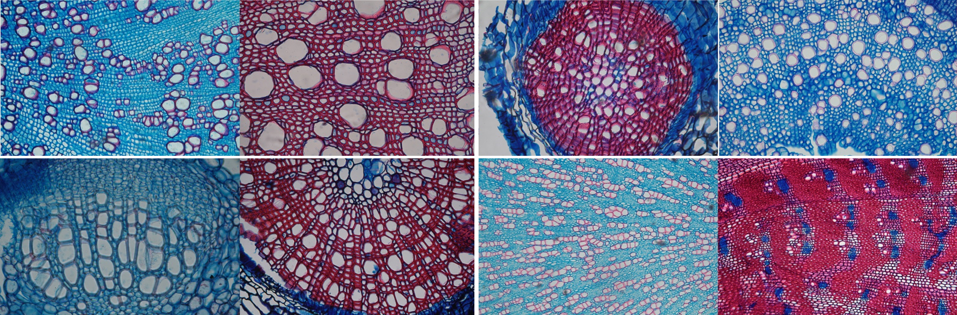

The following guideline should give some insight in the workflow that was used for the color analysis project conducted by Patrick Züst and Fritz Schweingruber in January 2016 at WSL Birmensdorf, Switzerland.

The workflow uses the public domain image processing program «ImageJ» to analyze the color ratios in the xylem. The resulting data was processed both with «R» and «Excel».

All the mentioned scripts and tables can be found on <https://www.dropbox.com/sh/f5qrqzpmky0am6o/AABci3pYGnoI_YOrnclgNs7aa?dl=0> . Make sure to give appropriate credit in case you use it for your own research. For more details and technical support you find the necessary contact information in the text-file *Contact.txt*.

Examples for microscopic pictures and the resulting analysis can be found in the folder *Example_Pictures*. Included are as well a Powerpoint-presentation and a concise handout summarizing the basic concept.

# PHOTOGRAPHS

## Creating folder structure

Every individual image should be saved in a separate folder which in the end not only stores the *.jpg*-file but also the *.roi*-selection and the resulting *.xls*-files. The whole folder structure can be created even before taking the first picture. If you have an overview of all your samples in Excel, you can use the script *Create_Folders* which is saved in the folder *Excel_Scripts* to create new folders named after your samples.

To use the script, create an Excel-sheet which includes an overview of your samples. Put the active workbook into a specific directory into which the created folders will be placed. Open the workbook and select the range of cells that you want to use as folder names. Click **Developer** > **Visual Basic**, a new **Microsoft Visual Basic for applications** window will be displayed, click **Insert** > **Module**, and paste the script mentioned above into the module.

Click the play-button to execute the code. All the selected cells have been transformed to folders which are placed in the same path as the active workbook.

While taking pictures you can now easily and quickly change between the different folders and don’t have to create a new folder for every single picture.

## Taking pictures

When taking microscopic pictures of your samples, you don’t have to worry about their orientation or about wood-anatomical standards. The most important thing is to correctly adjust the white balance so you don’t have any changes of the color hue.

If possible, try to choose a magnification which allows you to only photograph the xylem. It will save you a lot of time later. Try also to find a sector where the xylem is as representative as possible and doesn’t have any cracks or artefacts.

## Renaming Pictures

During the color analysis the file-name of the .jpg-images is used to describe the resulting data. To quickly rename all the pictures based on their folder name, you can for example use the tool «Bulk Rename Utility». To name them exactly the same as the folder they are saved in, use the following configuration:

On the left pane (the folder tree) select folders, in **Files (12)** check only «Files» and «Subfolders», in **Name (2)** select «Remove», in **Append Folder Name (9)** select «Prefix».  
Afterwards make sure you have all your files selected. You can preview the results on the right pane, and, if everything's ok, just press **Rename**.

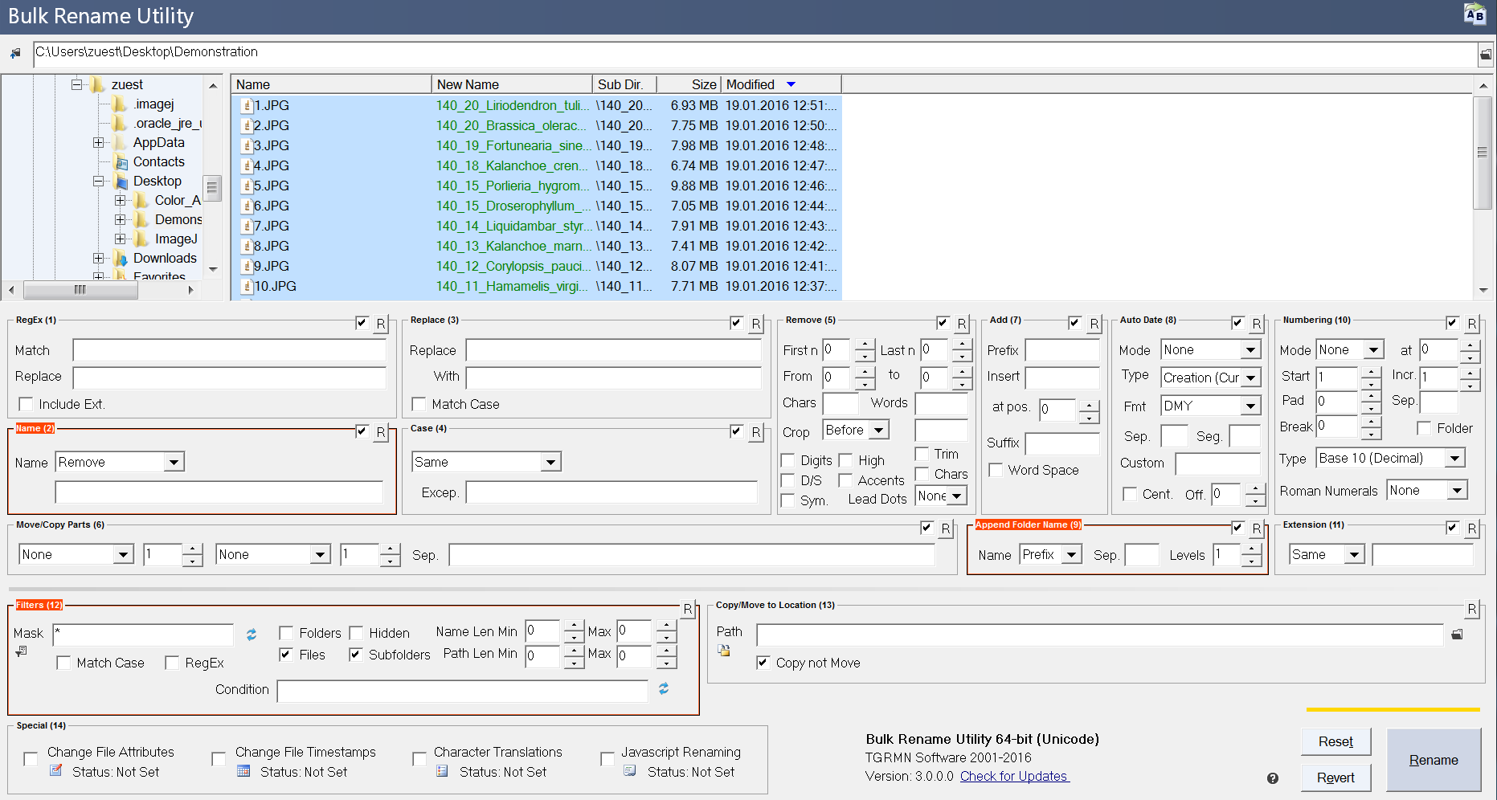

# Color Analysis

## Preparing «ImageJ»

The color analysis uses different scripts in «ImageJ». To make them accessible, you can either use the complete stand-alone software which is included in the folder *ImageJ* or – if you already have the software installed on your computer – you can take the scripts of the subfolders *macros* and *plugins* in the folder *ImageJ_Scripts* and place them in the equivalent folder of your «ImageJ» copy.

When «ImageJ» is started, you can access the batch-mode via **Plugins > Color_Analysis** and edit the individual macros via **Plugins > Macros > Edit**.

## Making a selection

In case it was not possible to only photograph the xylem, you can use «ImageJ» to define an area of interest. The colors will only be measured in the selected zone.

You can do that manually by opening an image, selecting the polygon tool, drawing a selection and afterwards saving it as «selection.roi» in the specified folder. (**File > Save As > Selection**)

There is also a macro which helps you to do exactly that automatically. After you installed the macro *selection.ijm* (**Plugins > Macros > Install**) you can start it with the shortcut *F4*. It checks whether there was already a selection made. If not, you can again draw a selection and with a click on the «OK»-button the selection is saved automatically.

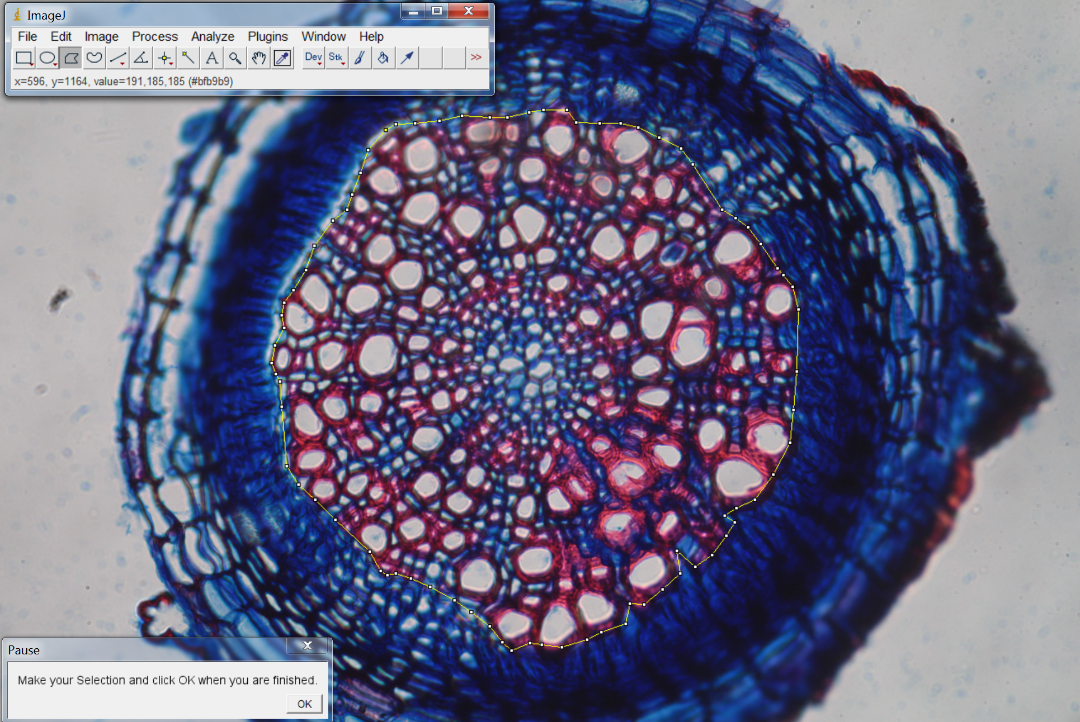

## Analyzing colors

The colors in a picture can be measured manually using the color threshold tool (**Image > Adjust > Color Threshold**). There you can configure the values for hue, saturation and brightness of the color range you want to include in your measurements. Everything that is (by default) shown red, is being recognized as color within the defined range.  
To get actual data, go to **Analyze > Analyze Particles…**, select «Summarize» and click on «OK». A new window Summary will be displayed where you have a percentage value for the area which is covered by the selected color. You can run this analysis for the three colors red, blue and white and afterwards save the resulting data as .*xls*-file.

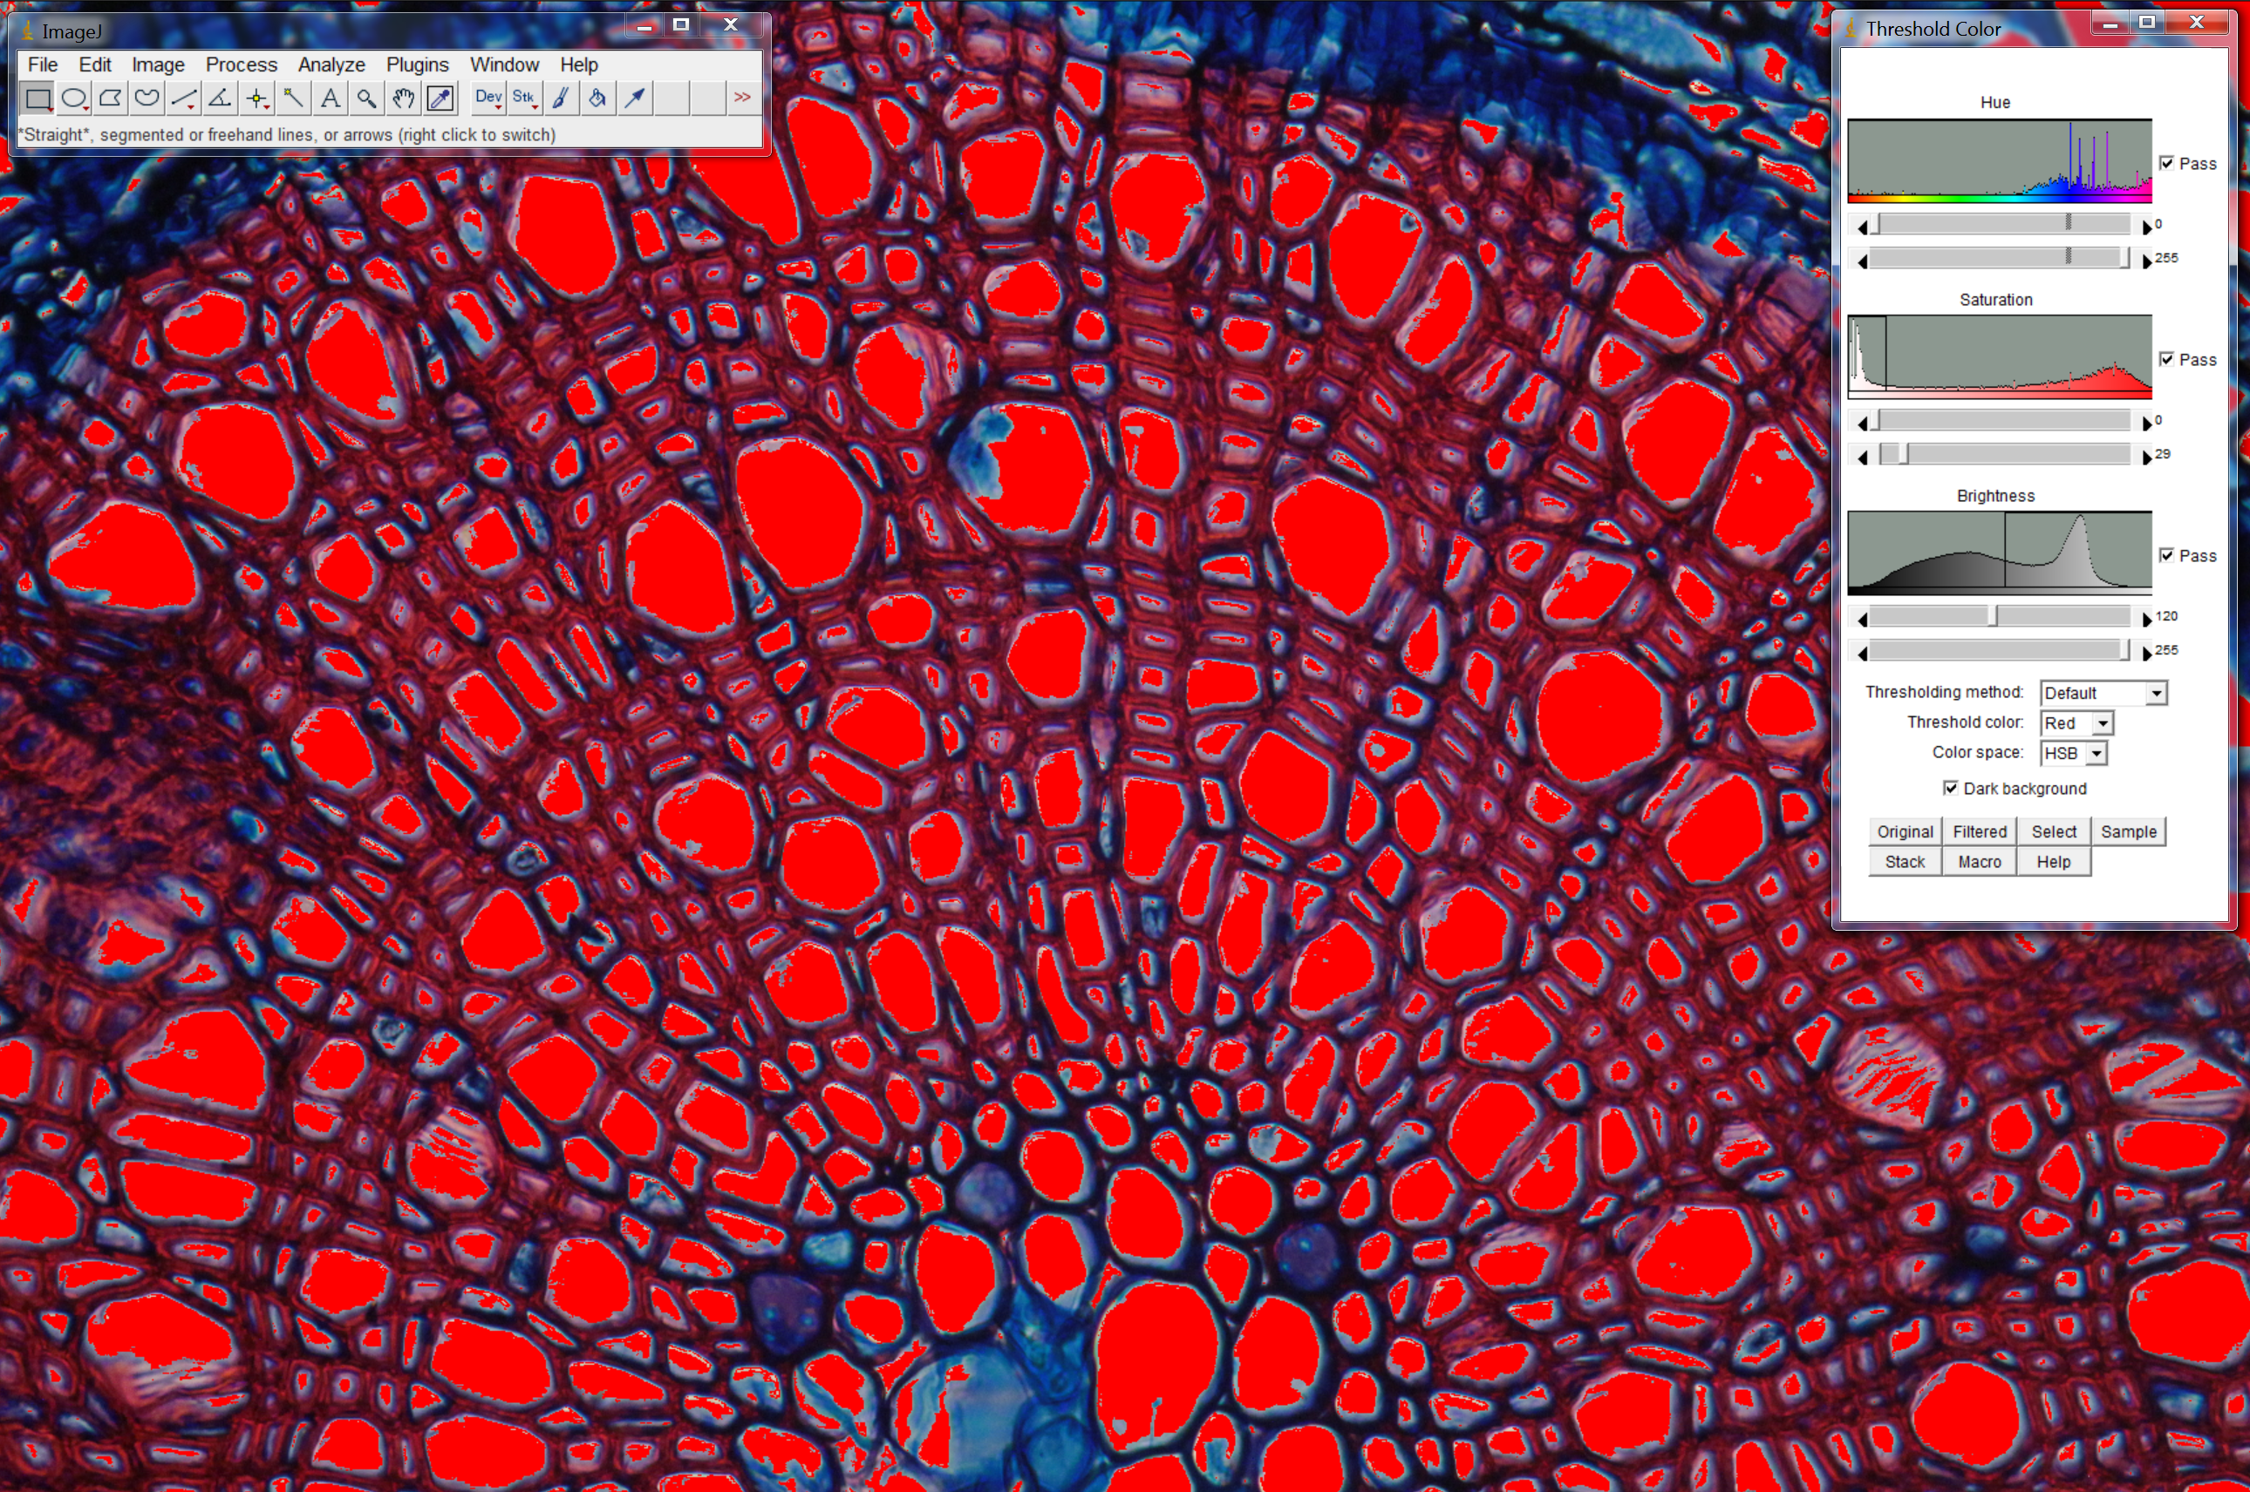

All of this can also be done automatically by using the macro *color_analysis*. You can change the values for the different color ranges in the parameters of the statement which calls the function *analyzeColors().* The script and the configuration that was used in Birmensdorf are shown below.

|  |  |  |  |  |  |  |
| --- | --- | --- | --- | --- | --- | --- |
| analyzeColors(40, 189, 40, 255, 40, 255, "stop", dir, imageTitle, "red");  analyzeColors(125, 189, 40, 255, 120, 255, "pass", dir, imageTitle, "blue");  analyzeColors(0, 255, 0, 29, 120, 255, "pass", dir, imageTitle, "white"); | | | | | | |
| **Color** | **Hue** | **P.** | **Saturation** | **P.** | **Brightness** | **P.** | |
| *red* | 40-189 |  | 40-255 | X | 40-255 | X | |
| *blue* | 125-189 | X | 40-255 | X | 120-255 | X | |
| *white* | 0-255 | X | 0-29 | X | 120-255 | X | |

If you have multiple files saved in subfolders, you can use the batch-mode to process all of them automatically. Access it by going to **Plugins > Color_Analysis > Batch_Color**, select the main folder and press «OK». Every *.jpg-*image that is found within these subfolders will be analyzed, the selections will be taken into account and the resulting data will be saved as *.xls*-file in the specific image folder.

## Random Fields

The analysis can not only be done for the whole image, but also for random parts of it. This might be a statistically more reliable approach because the random measurement fields generate multiple values for one picture which afterwards can be compared.

To start the batch-mode for the random measurements, go to **Plugins > Color_Analysis > Batch Random**. The fields will be distributed randomly and the results will be saved in the same folder as the original picture.

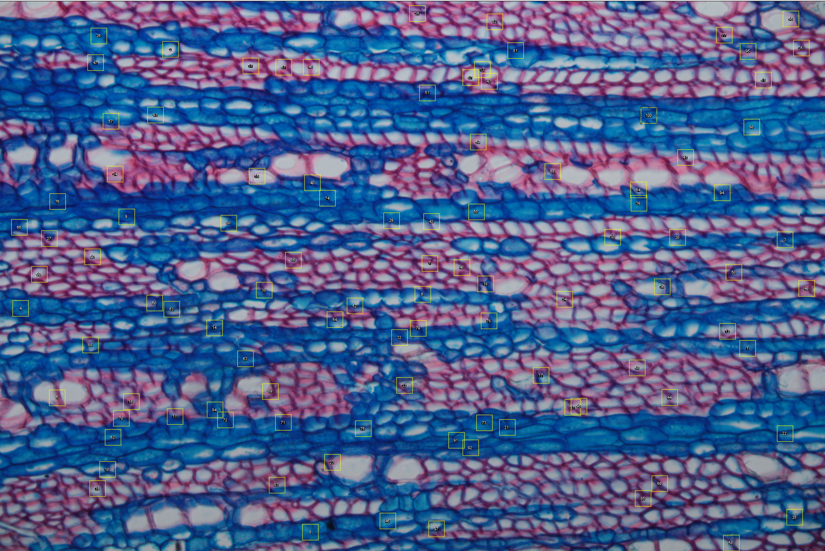

# Processing of the data

## Merging Excel Files

To process the data, it is necessary to merge all the individual Excel-sheets. To do that, use the search tool included in the windows explorer and search for «.xls» to gather all the individual files. Copy them in a new folder and afterwards open a new workbook. It is important to save this file at another location than the files that should be merged.

Click **Developer** > **Visual Basic**, a new Microsoft Visual Basic for applications window will be displayed, open a new module by double-clicking «ThisWorkBook» on the left sheet menu. Paste the code you can find in the folder *Excel_Scripts* and change the folder as mentioned on comment in the macro code.

Click the «Play»-button to execute the code. All the selected files have been merged in the active workbook.

## Combining Data in R

To include the resulting data in an existing spreadsheet, the most efficient way is to use the programming language «R». An example script that of course needs to be adjusted to your personal needs can be found in the folder *R_Scripts*.

It uses a data frame *Summary*, meaning the combined color analysis data, and a data frame *Overview*, meaning the spreadsheet in which the data should be included.